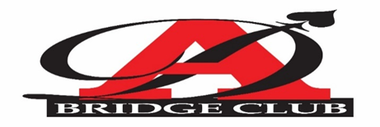

If you play Bid Whist
Spades-Hearts-Pinochle-Bridge or No Card Game at All

WOULD YOU LIKE TO LEARN TO PLAY BRIDGE?

THE AZTEC DUPLICATE BRIDGE CLUB

WOULD LOVE TO TEACH YOU HOW TO PLAY!
This Class is Free but… Students must agree to: Attend all classes
Purchase Book before First Class-(Audrey Grant-Bridge Basics 1 @ $11) and
Coffee and Water-Served
Saturday Afternoon @ 2:30 PM-4:30 PM.
March 7th-14th 21st and 28th
Sunday Afternoon-@ 2:30-4:30 PM-
March 8th-15th-22nd-29th

Malcom X Library
5148 Market St, San Diego, CA 92114
TO REGISTER FOR THE CLASS--
Send Name and Contact Email/Telephone Number to
aztecbridgeclub@gmail.com or msk6568@yahoo.com
Call-(619) 346-0308

