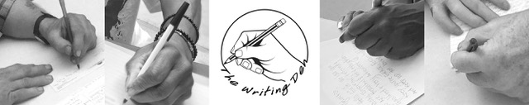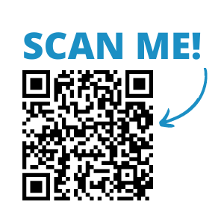

**San Diego Central Library**

**@ Joan Λ Irwin Jacobs Common**

330 Park Blvd, 92101 · 619-236-5800

sandiego.librarymarket.com/events/the-writing-den

FREE EVENT!

Writing supplies

will be Provided!

The Writing Den will help you communicate and connect through the power of handwriting a greeting card, letter or even something just for you.

Christian Michaels facilitates a FREE monthly small group brainstorming, drafting, and sending handwritten correspondence. Supplies, stamps, and support will be provided!

Monthly, Last Monday · 2-4 PM · 1st Floor Lobby

Ready to put pen to paper?

Welcome to

The Writing Den